NAME: ______________________________________ Date: ________________________

Lab Partner’s: ____________________________________________

Access the University of Colorado’s PhET simulation
Energy Skate Park

Select “Graphs” and use the default skate track configuration. Click “Reference Height” and place the blue dashed line directly at the bottom of the track and the skater at the top of the track.

- Sketch the track (or insert a screenshot of it) and label the following positions.
Earth
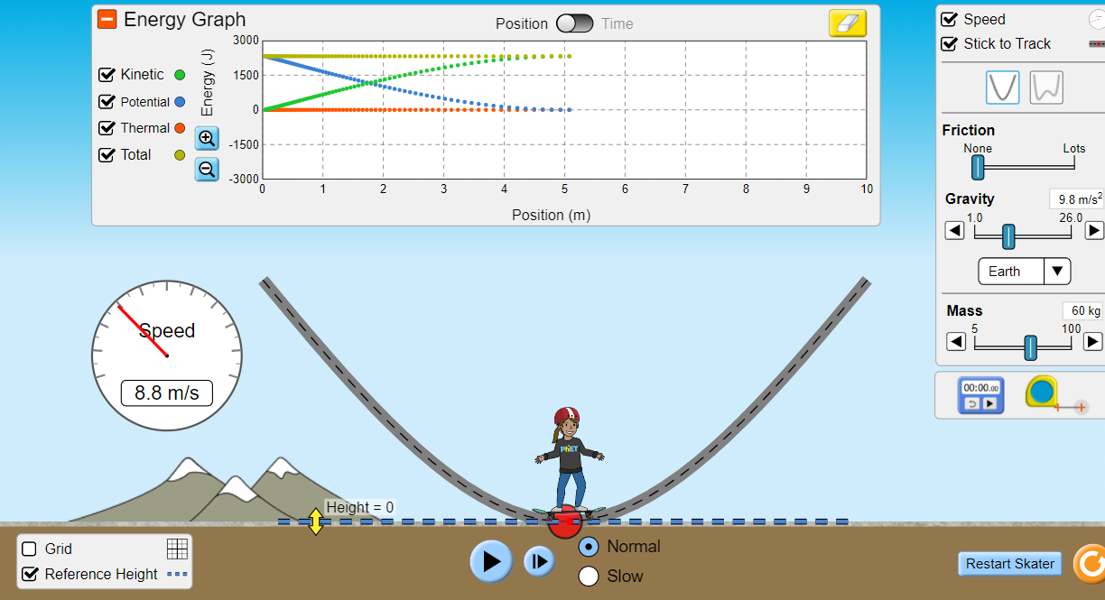
- The skater is at his maximum speed

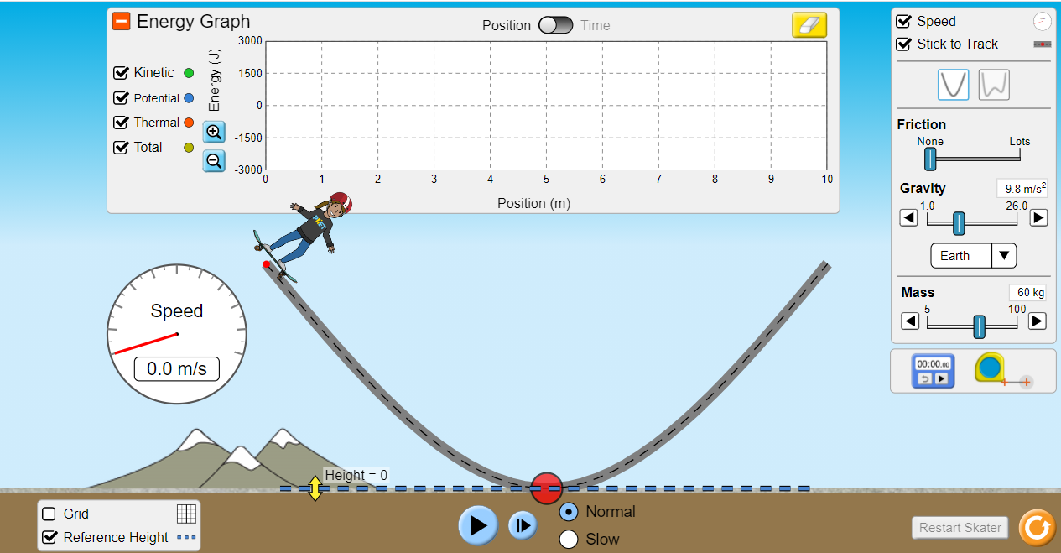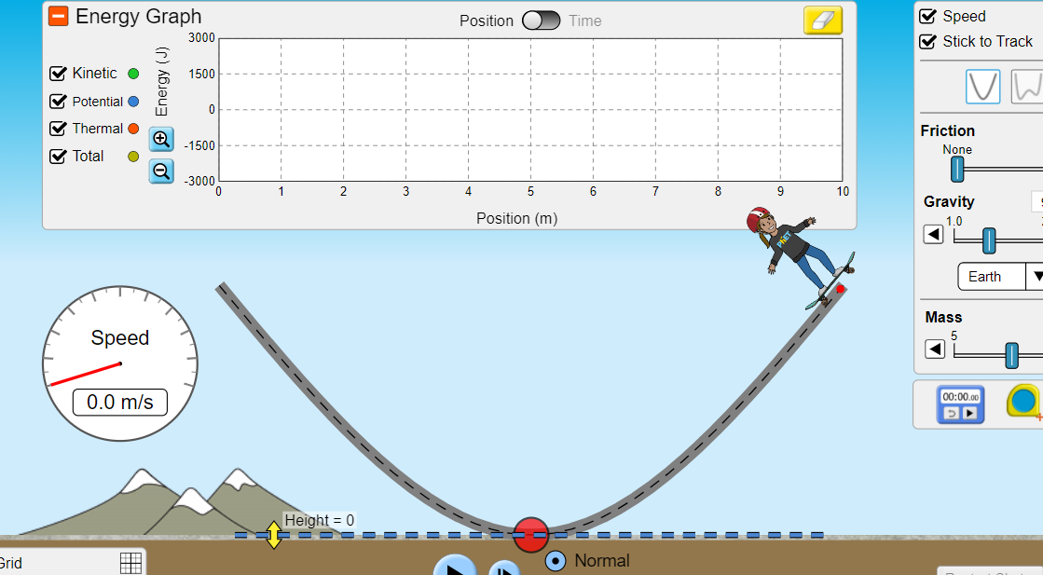
- The skater is stopped
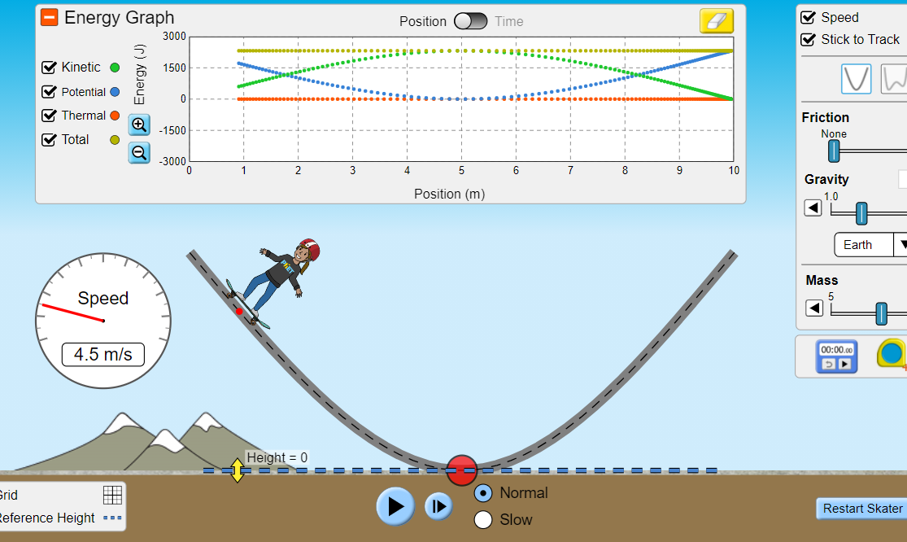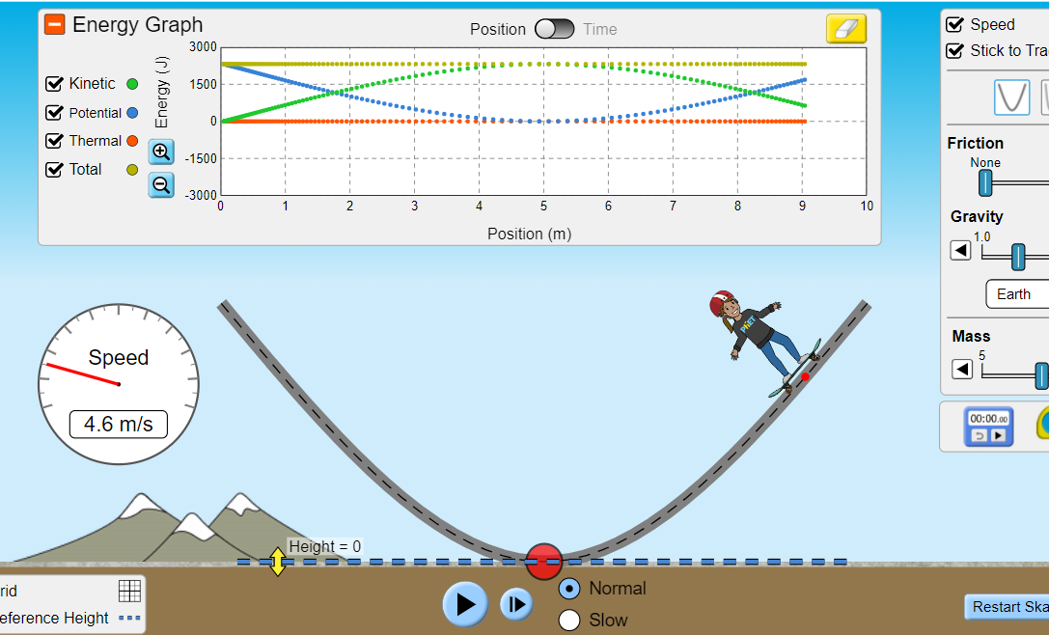
- The skater is going his average speed

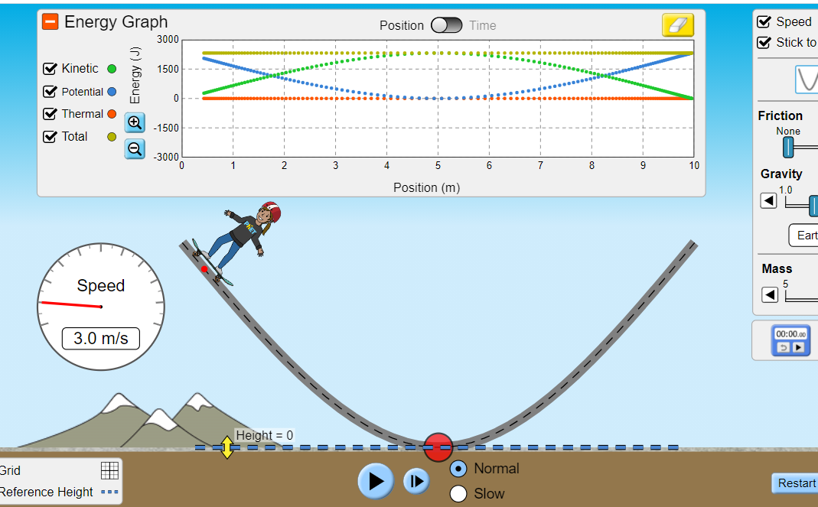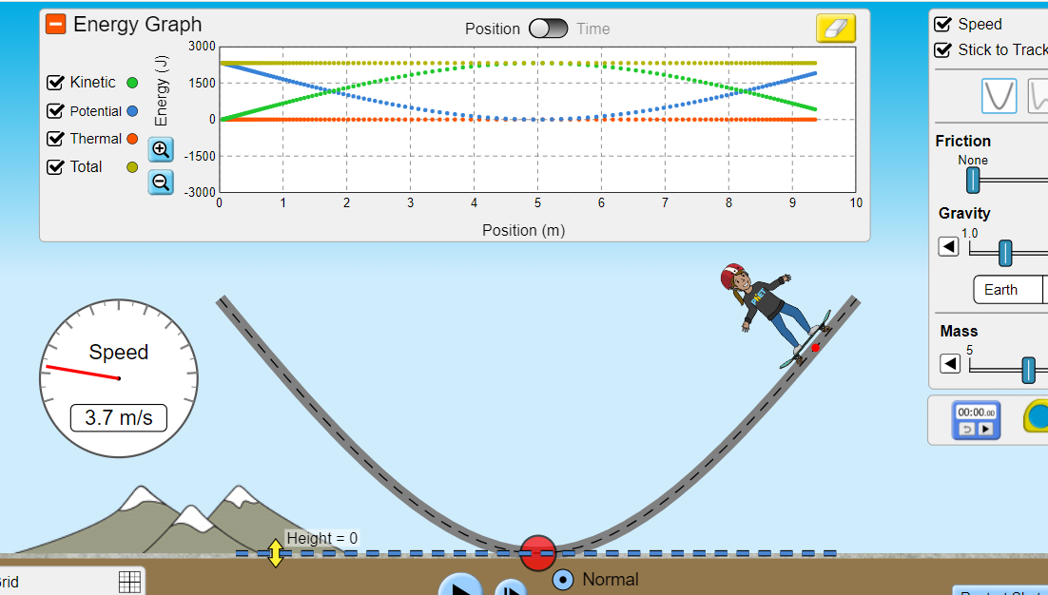
- The skater is going slow

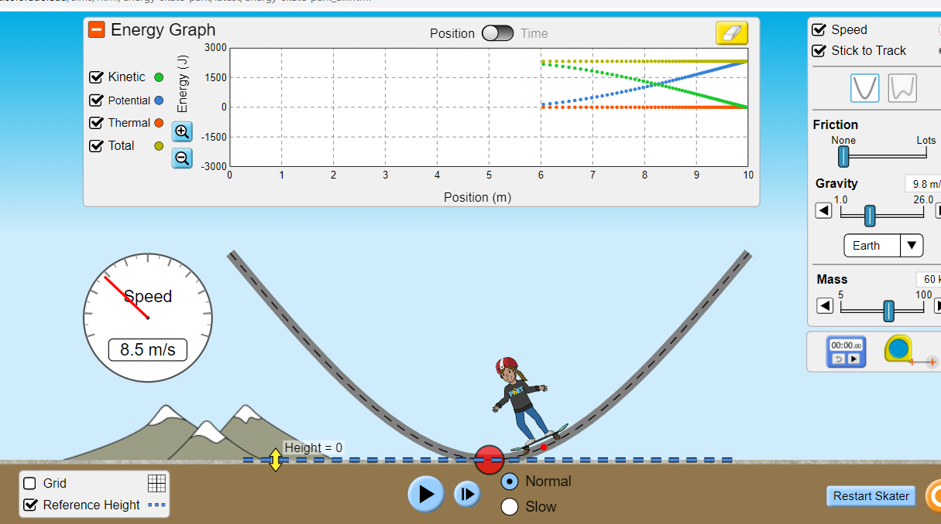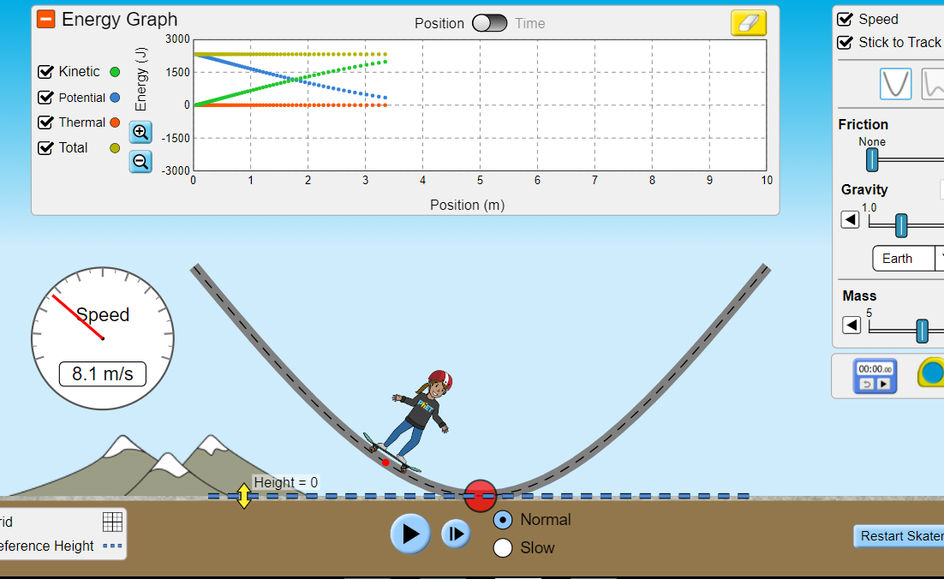
- The skater is going fast

2.) What will be the speed of the 60 kg Skater at 2 seconds? (You can use the Energy vs Time graph and the speedometer. Place the vertical line on the graph at 2 s). it is about 8.2m/s

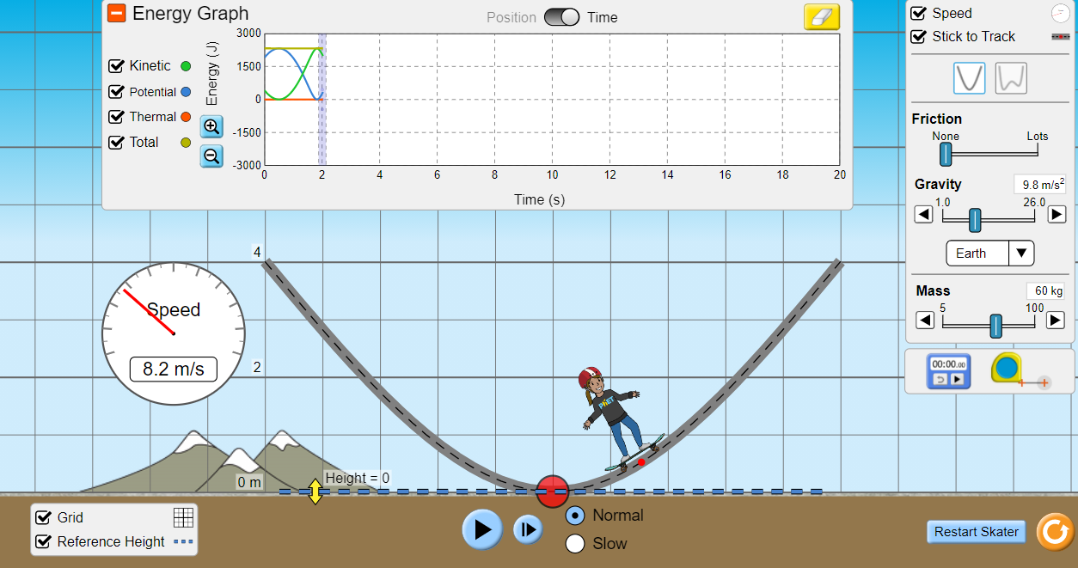
3.) At what height is the Skater at 2 seconds?
The height is about 0.5 m.

4.) What is the kinetic, potential, and total mechanical energy at 10 seconds?
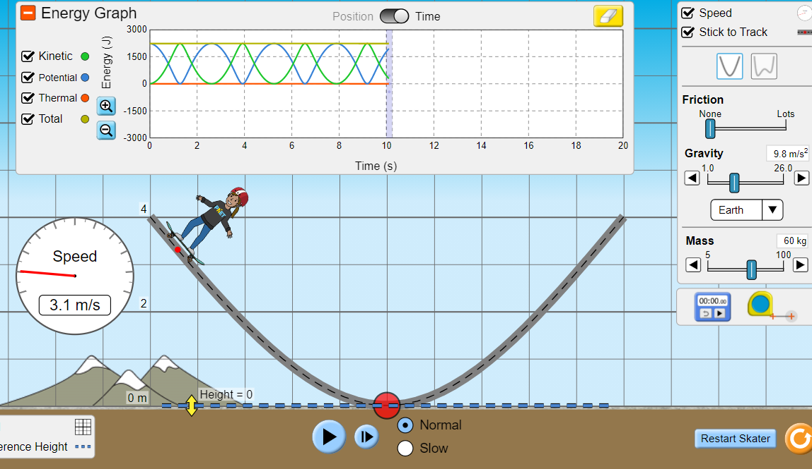
Kinetic energy is about 500 J
Potential energy is about 1800J
Total mechanical energy = 2300J
5.) Repeat questions 1 to 4 for the moon, and then for Jupiter. Explain why the results differ between the Earth, moon, and Jupiter.
Moon
- Sketch the track (or insert a screenshot of it) and label the following positions.

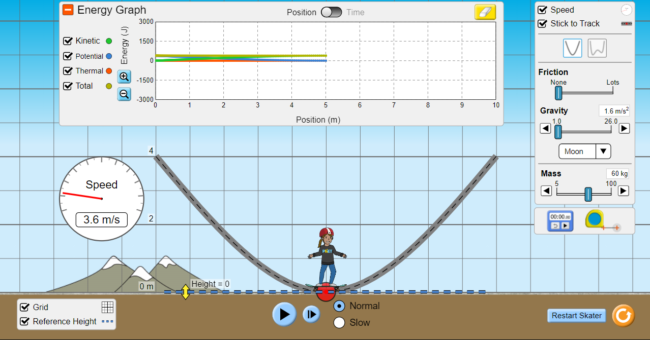
- The skater is at his maximum speed
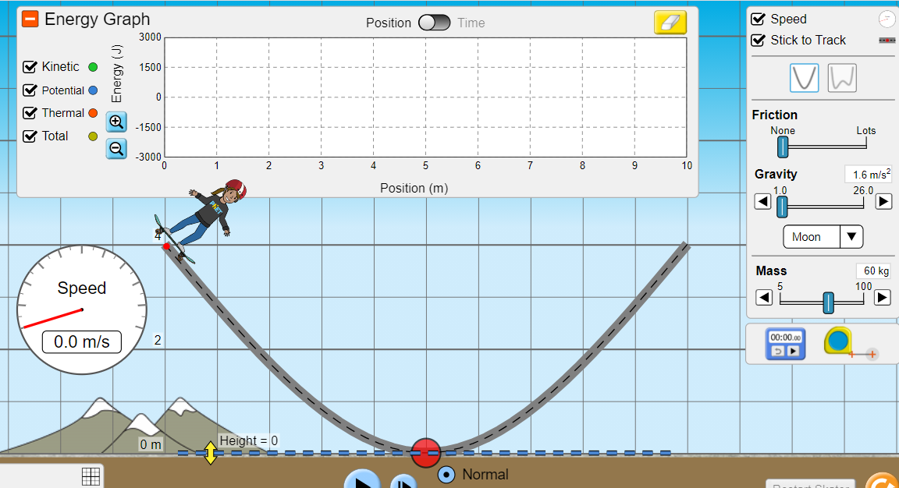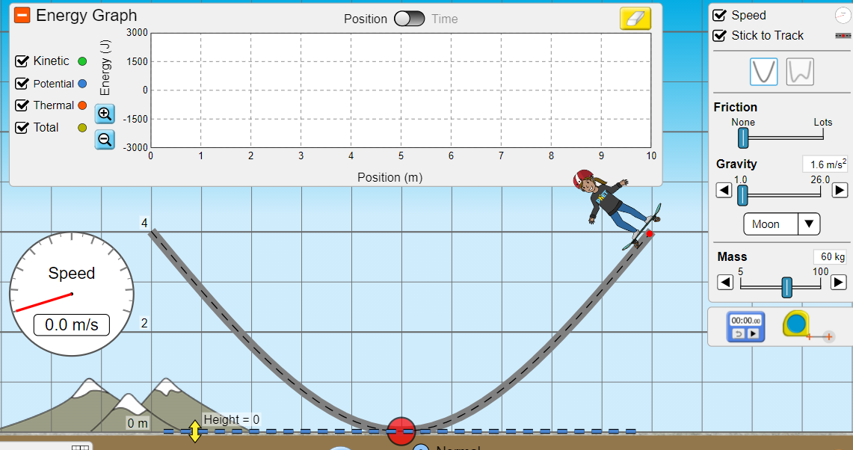
- The skater is stopped
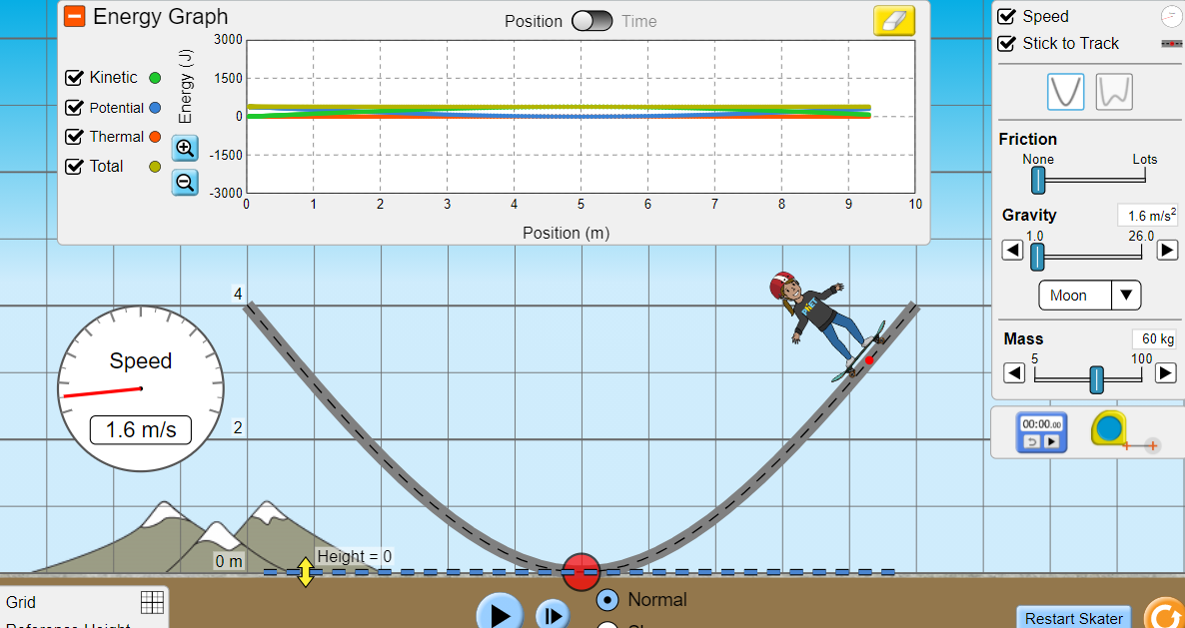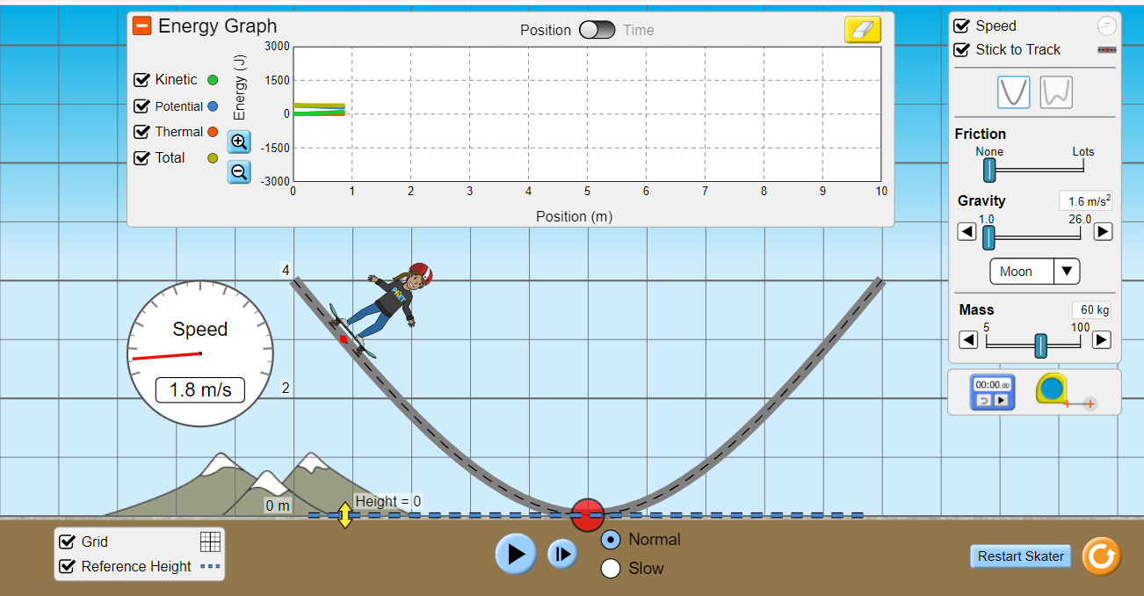
- The skater is going his average speed
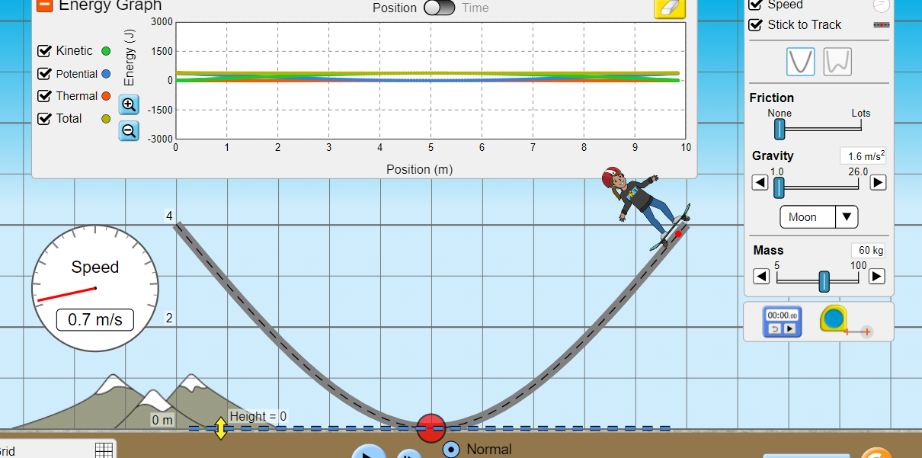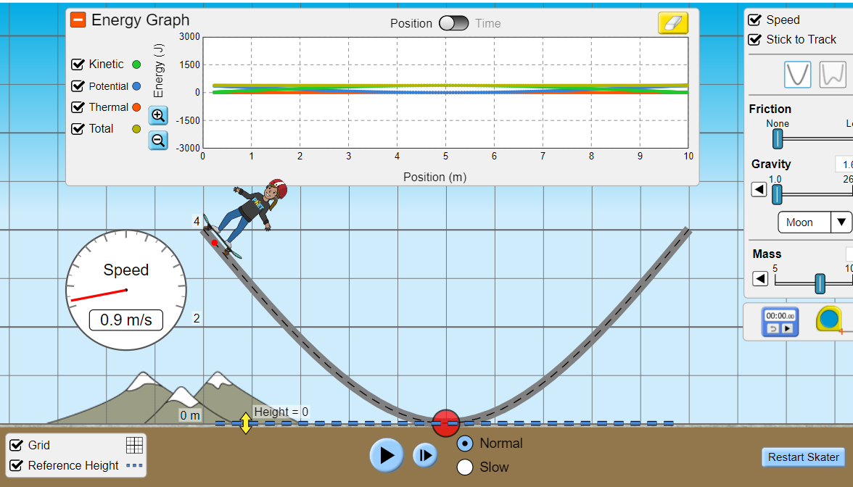
- The skater is going slow

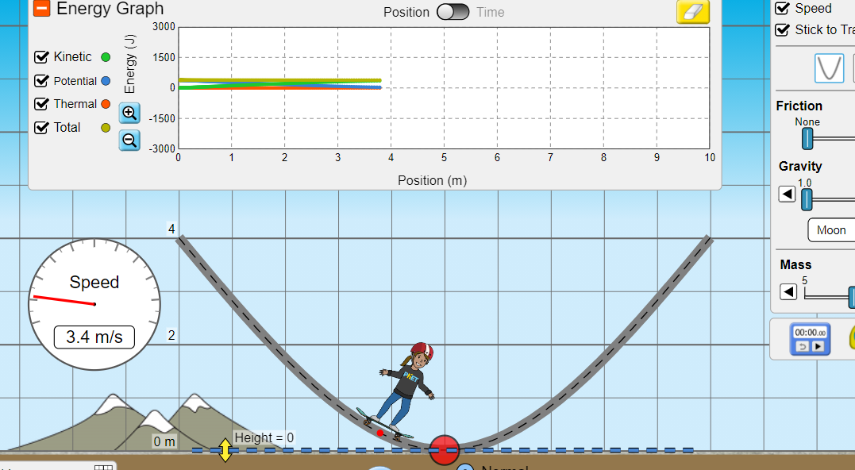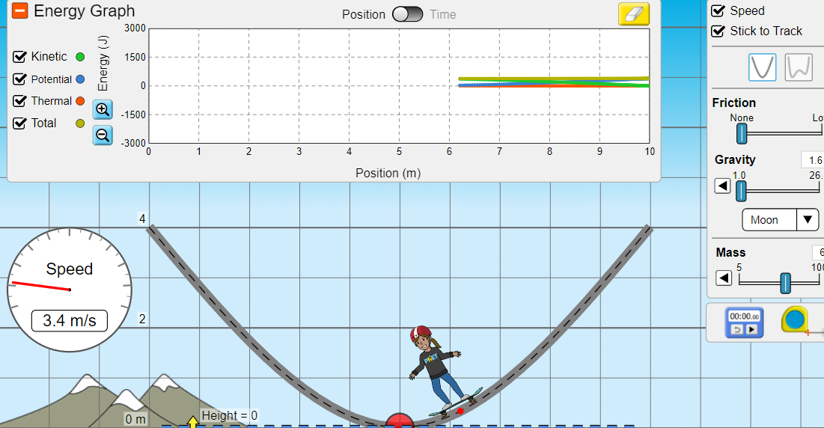
- The skater is going fast

2.) What will be the speed of the 60 kg Skater at 2 seconds? (You can use the Energy vs Time graph and the speedometer. Place the vertical line on the graph at 2 s). it is about 2.6 m/s

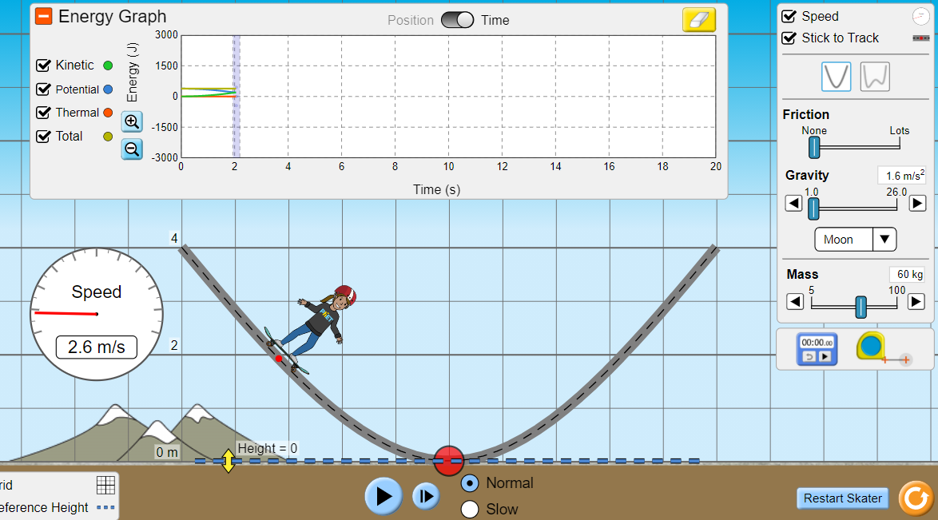
3.) At what height is the Skater at 2 seconds?
The height is about 1.8 m.

4.) What is the kinetic, potential, and total mechanical energy at 10 seconds?
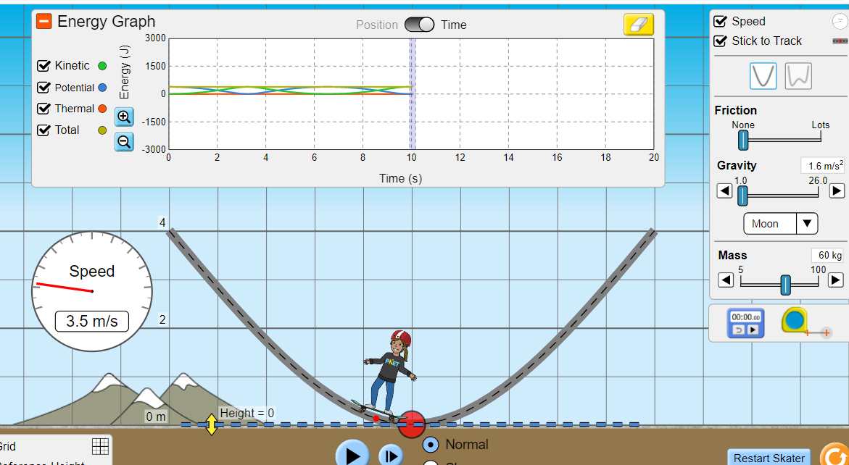
Kinetic energy is about 500 J
Potential energy is about 0 J
Total mechanical energy = 500J
Jupiter
- Sketch the track (or insert a screenshot of it) and label the following positions.
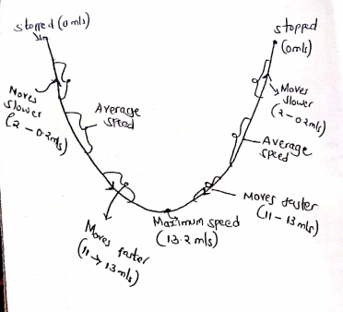
Sketch of Skater’s position in Jupiter

2.) What will be the speed of the 60 kg Skater at 2 seconds? (You can use the Energy vs Time graph and the speedometer. Place the vertical line on the graph at 2 s). it is about 5.8 m/s
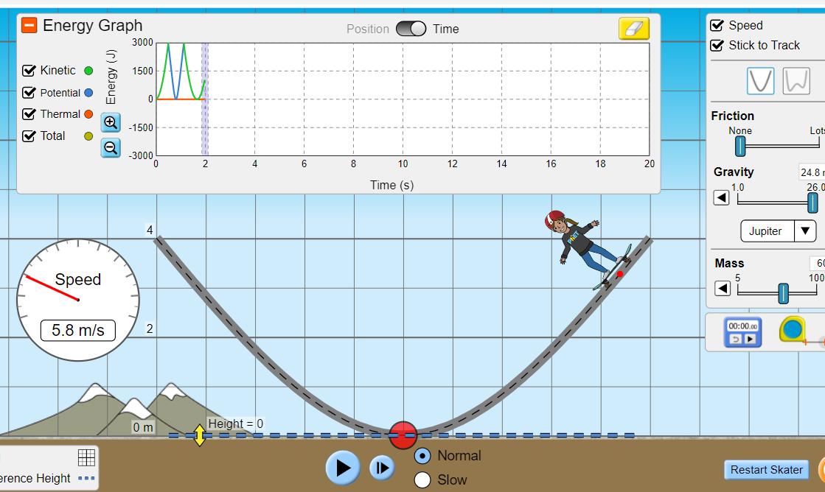

3.) At what height is the Skater at 2 seconds?
The height is about 3.3 m.

4.) What is the kinetic, potential, and total mechanical energy at 10 seconds?

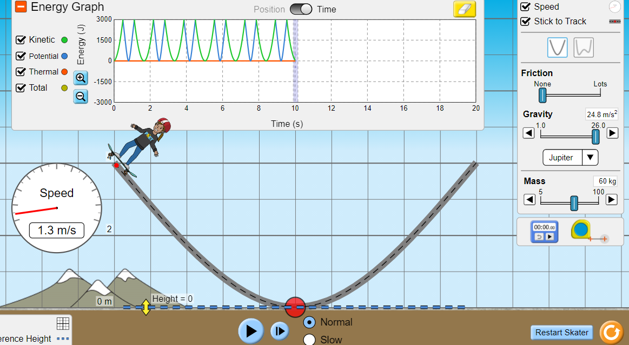
Kinetic energy is about 0 J
Potential energy is about 0 J
Total mechanical energy = 0J

Explain why the results differ between the Earth, moon, and Jupiter.
The results differ in that the force of gravity is different in these three scenarios. Force of gravity affects the speed of the skater the higher the gravitational force, the higher the acceleration and therefore the higher the speed of an object.
The speed of skater on the earth is average, on the moon it was extremely low and then it was faster on the planet Jupiter. This therefore shows that the force of gravity was lower on the moon, resulting in lower speed of the skater and the average gravitational force on the earth resulted on the skater experiencing average speed and finally, the higher gravitational force on Jupiter resulted in the skater experiencing a higher skating speed.

6.) Select the next track configuration, sketch the track (or insert a screenshot) and label the following positions.

- The skater is at his maximum speed
- The skater is stopped
- The skater is going his average speed
- The skater is going slow
- The skater is going fa

st

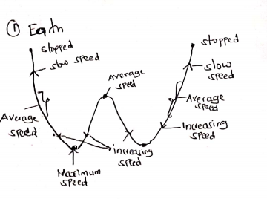

A sketch of skater’s position /speed on earth.
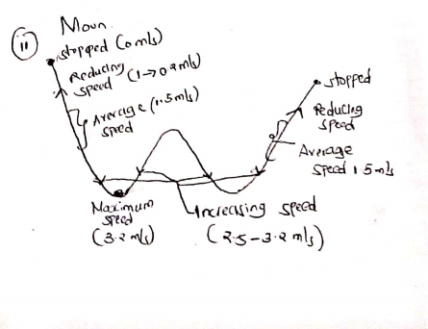
A sketch of skater’s position /speed on moon.

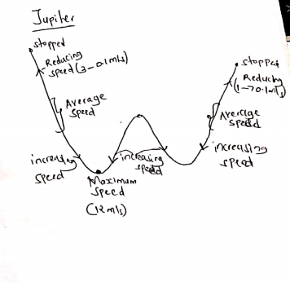
A sketch of skater’s position /speed on Jupiter.

7.) Use the last skate track configuration, modify it a bit so that its Energy-Position graph matches the one below. Label in this graph the 5 positions in the prior question.

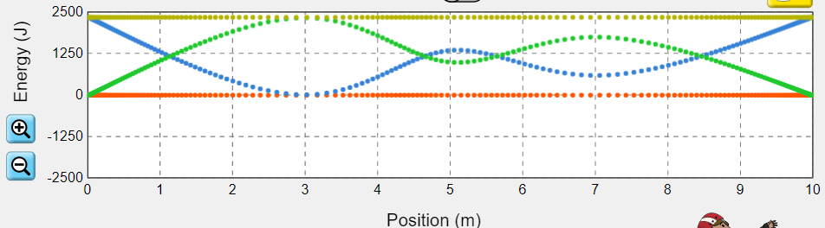
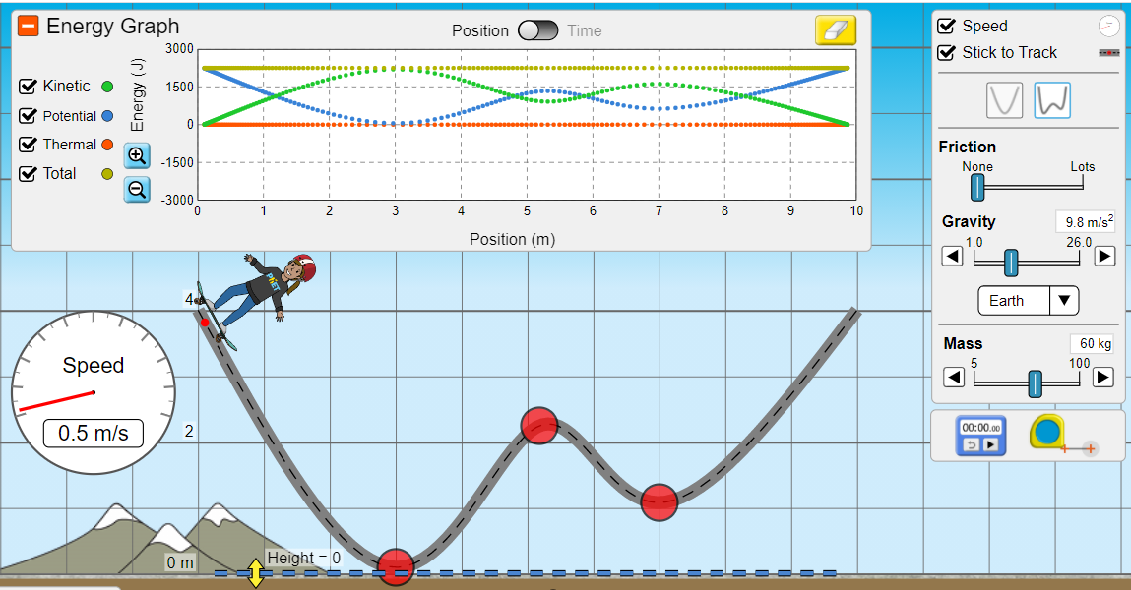

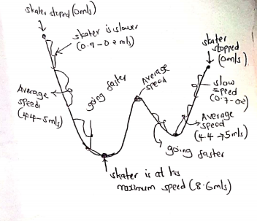

8.) Add an amount of friction to the original skate track configuration.
a) What is the kinetic, potential, thermal, and total mechanical energy after 2 seconds?

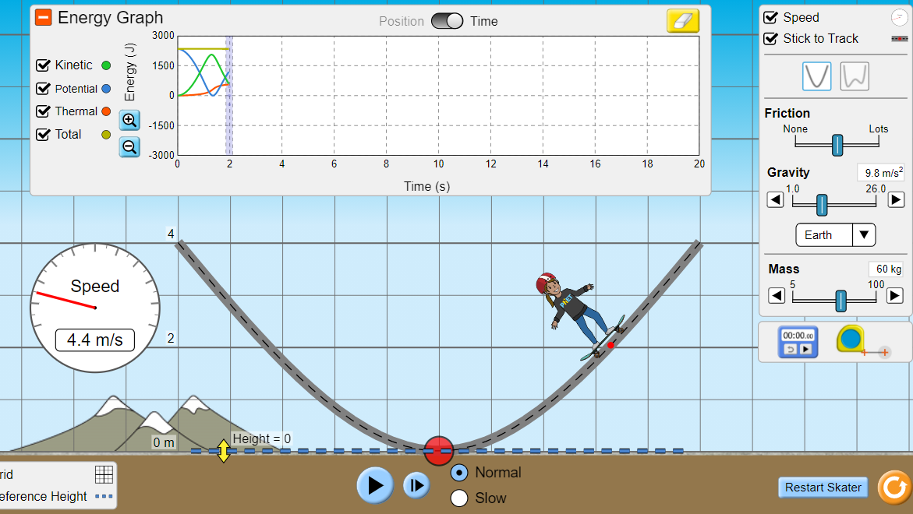
Kinetic energy is about 600 J
Potential energy is about 1200 J
Total mechanical energy = 1800J

b) Explain the transfer of mechanical energy throughout the simulation as the skater finally
Comes to rest.

It finally comes to rest due to frictional energy. Friction energy is the energy acting against motion of an object, what causes motion is kinetic energy, hence when friction energy offsets kinetic energy, the object comes to rest and the kinetic energy is converted to heat energy in the process.

c) Label each energy source as conservative or non-conservative. Explain each case.

Kinetic energy = conservative
Potential energy= conservative
Friction energy = non-conservative
Thermal energy = conservative

d) Insert a screenshot of the simulation with this configuration, showing the Energy vs Time graph.

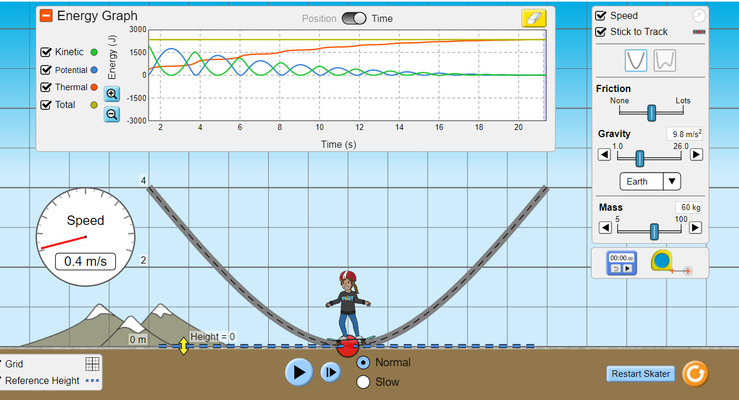
9.) Select “Intro” and choose the track with the loop. Fix two of the variables (Friction, Gravity, Mass) and vary the other from minimum to maximum values. Observe what happens to the motion and energy graph in each case. Record your observations.

With fixed Friction and gravity remain fixed and the mass of the skater is changed from minimum to maximum, the speed of the skater does not change it stills move all over the loop with the same speed as it was when with minimum mass.
With fixed friction and mass, as you increase gravity from minimum to maximum, the speed of the skater increases. Hence as you increase gravity, the speed also increases.
With fixed gravity and mass, as you increase friction from minimum to maximum, the speed of the skater decreases drastically and at some point not able to move past the loops and then with time, skater comes to rest.

CONCLUSION
The experiment was concluded with success, what was noted is that gravity and friction affects the speed of an object. Gravity for instance as it increases, the speed of the moving object increases and as gravity reduces, the speed of the object reduces as well. Gravity is like an acceleration force which directly affects the kinetic energy (energy causing objects to be in motion). What is noted also is that as kinetic energy increases, potential energy is reducing, because speed increases as you go towards the lowest point and it is at the lowest point that low potential energy is experience.
Friction on the other hand as it increases, the speed of an object reduces until it finally comes to rest. Friction opposes kinetic energy and in the process acting against motion of an object and converting kinetic energy to thermal energy. You will notice that as an object comes to rest due to friction energy, thermal energy of the surrounding will have increased.
Finally, what was also noted is that the mass of an object does not affect the speed of an object unless we have external forces like friction and kinetic energy.

